PENETRATION TESTING REPORT
FOOTPRINTING & NETWORK SCANNING PHASES
W2-PM-FINAL | CYBERSECURITY | NETWORKWALKS
Executive & Technical Metadata
- Pentester Name: Abdullah Shamshad (Cybersecurity Professional / SOC Analyst Trainee)
- Program / Batch: B084-Networkwalks
- Date: 17 August 2026
- Modules Completed:
  - W2-PM1 (Multiple Kali Reconnaissance Tools)
  - W2-PM5 (Zenmap Network Scanning & Topology)
- Client / Target:
- networkwalks.com (secured written permission)
- Local LAN Subnet Network
- Permission Secured from Client: Yes
- Phases Covered:
- Phase 1: Reconnaissance & Footprinting
- Phase 2: Scanning & Network Discovery
- Phase 3–5: In Progress
1. Liability Disclaimer
I have performed these activities only on the systems & devices where I had secured written permission or the devices/systems that I own myself. All these materials are for education and research purpose only. Do not use anything from here to break the law. The instructor, the authors and Networkwalks are not responsible for what you do with this knowledge. Every action you take is your own responsibility. Misuse can lead to criminal charges, heavy fines, loss of your job and a permanent record. In most countries unauthorised access is a crime even when nothing is damaged.
2. Introduction
This report covers footprinting the networkwalks.com domain using multiple Kali Linux tools (W2-PM1) and scanning my own local network with Zenmap (W2-PM5). One module covers the footprinting phase and the other covers the scanning phase, so together they show how an attacker moves from gathering public information to mapping live hosts on a network. It is the Week 2 part of my ongoing internship program at Networkwalks.

All commands were run in Kali Linux (footprinting) and on a Windows PC with Zenmap installed (scanning). Every step below includes the exact command used, the result I observed, a screenshot placeholder as evidence, and a short note on why the finding matters from an attacker's point of view.
3. Tools Used
Tool | Purpose
Kali Linux & Windows | Operating systems used for reconnaissance activities
WHOIS | Find domain registration details (owner, dates, name servers).
WhatWeb | Fingerprint web technologies (server, CMS, plugins, IP).
Nslookup | Resolve the domain name to its IP address using DNS.
Curl -I | Read the HTTP response headers of the website.
Wafw00f | Detect whether a Web Application Firewall protects the site.
DNSRecon | Enumerate all DNS records (NS, MX, SPF, TXT, SRV).
Zenmap (Nmap GUI) | Scan the local subnet to find live hosts, IPs and MAC addresses.
Windows CMD | Local IP and MAC address identification
4. Activities Performed
4.1 Footprinting & Reconnaissance
I performed reconnaissance against the networkwalks.com domain using six Kali Linux tools: WHOIS, WhatWeb, Nslookup, Curl, Wafw00f and DNSRecon. Each tool was used to collect a different type of information about the target.

- Task 1: WHOIS Domain Registration Details
  - Command: whois networkwalks.com
  - Observation: Obtained publicly available domain registration information, registrar details, registration/expiration dates, and authoritative name servers.
- Task 2: WhatWeb Technology Fingerprinting
  - Command: whatweb networkwalks.com
  - Observation: Identified technologies used by the website including WordPress 7.0.4, WP Download Manager 3.3.58, web server parameters, and HTTP status codes.
- Task 3: Nslookup DNS Resolution
  - Command: nslookup networkwalks.com
  - Observation: Resolved the domain name to its primary IPv4 address (192.232.216.135).
- Task 4: Curl HTTP Response Headers
  - Command: curl -I https://networkwalks.com
  - Observation: Inspected raw HTTP response headers, revealing backend server banners and exposing the WordPress REST API endpoint /wp-json/.
- Task 5: Wafw00f WAF Detection
  - Command: wafw00f https://networkwalks.com
  - Observation: Evaluated active perimeter security and detected active protection by ModSecurity (SpiderLabs) Web Application Firewall.
- Task 6: DNSRecon Record Enumeration
  - Command: dnsrecon -d networkwalks.com
  - Observation: Enumerated DNS resource records including A, AAAA, MX, NS, SPF/TXT, and SOA records for comprehensive attack surface mapping.
4.2 Network Scanning with Zenmap
For the second activity, I used Zenmap to perform network discovery on my local network. The practical required me to identify my local IP address and subnet, discover live hosts, identify their IP and MAC addresses, and generate a network topology.

- Local Network Discovery: Used ipconfig /all on Windows CMD to identify host local IP address, subnet mask, and default gateway.
- Zenmap Ping Scan: Configured Zenmap with a Ping Scan targeting the local subnet range to discover active live nodes without full port sweeps. Identified live hosts (e.g., 10.0.0.1, 10.0.0.4, 10.0.0.19, 10.0.0.5) along with their respective MAC addresses.
- Topology Generation: Opened Zenmap's Topology view, enabled the legend display, and saved the network topology graph.
5. Risk Analysis / Impact
# | Risk / Finding | Evidence / Observation | Potential Impact | Risk Level
1 | Web technology information exposed | WhatWeb identified WordPress and WP Download Manager | Attackers may use exposed technology/version information to identify software requiring further security review | Medium
2 | Server IP address identifiable | Nslookup resolved the domain to 192.232.216.135 | Provides information about the network location of the web service | Low
3 | HTTP technical information exposed | Curl returned HTTP response headers and exposed /wp-json/ | May assist technology fingerprinting and further enumeration | Low
4 | WAF technology identifiable | Wafw00f identified ModSecurity (SpiderLabs) | Reveals information about the web application’s security architecture | Low
5 | DNS infrastructure information exposed | DNSRecon identified DNS, mail and service-related records | DNS information can help build a broader infrastructure profile | Medium
6 | Multiple live hosts visible on local network | Zenmap identified active live hosts on the local network | Unknown or unauthorized devices may potentially be present on a network | Medium

Note: Risk levels range across Critical, Medium, and Low. The risks above are observations from the footprinting and scanning exercises, not confirmed vulnerabilities. No exploitation or vulnerability validation was performed as part of these two modules.
6. Recommendations
- Review publicly exposed technology information: Organizations should regularly review what information about their web technologies, CMS, and plugins is publicly visible.
- Keep software updated: CMS platforms, plugins, and web technologies should be regularly updated and reviewed against current security advisories.
- Review HTTP headers: HTTP response headers should be reviewed to remove unnecessary server version disclosure or technical details.
- Review DNS records regularly: DNS records should be audited periodically to ensure only essential services and records are publicly exposed.
- Properly configure and monitor the WAF: Maintain and tune the Web Application Firewall (ModSecurity) to block automated scanner probes and naive attacks.
- Perform regular internal network discovery: Organizations should periodically scan their internal networks to maintain complete asset inventory.
- Investigate unknown devices: Any unexpected or unauthorized host discovered during network sweeps should be investigated immediately.
- Maintain network documentation: Network topology, IP allocations, and host inventories should be updated regularly.
- Perform security testing with authorization: Ensure all scanning and reconnaissance activities strictly adhere to pre-approved scope and written authorization.
7. Conclusion
During Week 2 of my Cybersecurity internship, I completed practical activities covering footprinting, reconnaissance, and network scanning. In the footprinting activity, I used six Kali Linux tools to collect information about the target domain. In the network scanning activity, I used Zenmap to identify local network configurations, discover active hosts, and generate visual topology graphs. Information gathering is a fundamental phase in cybersecurity, providing crucial insights into perimeter security and internal asset visibility while remaining strictly within authorized boundaries
8. Evidences Collected (Screenshots Placement)
- Evidence (WHOISOutput): 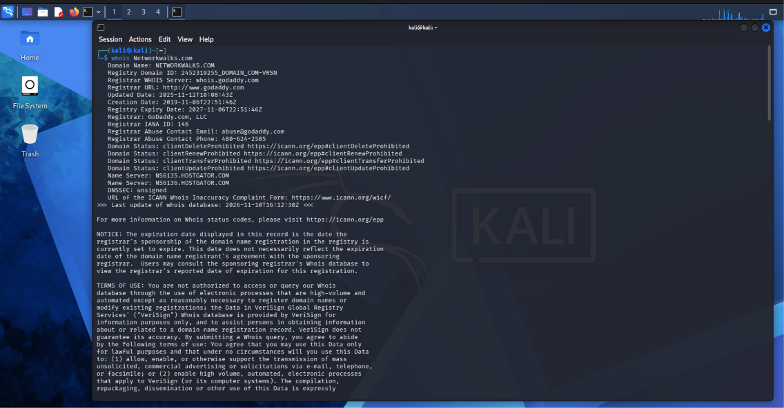
- Evidence 2 (WhatWeb Output): 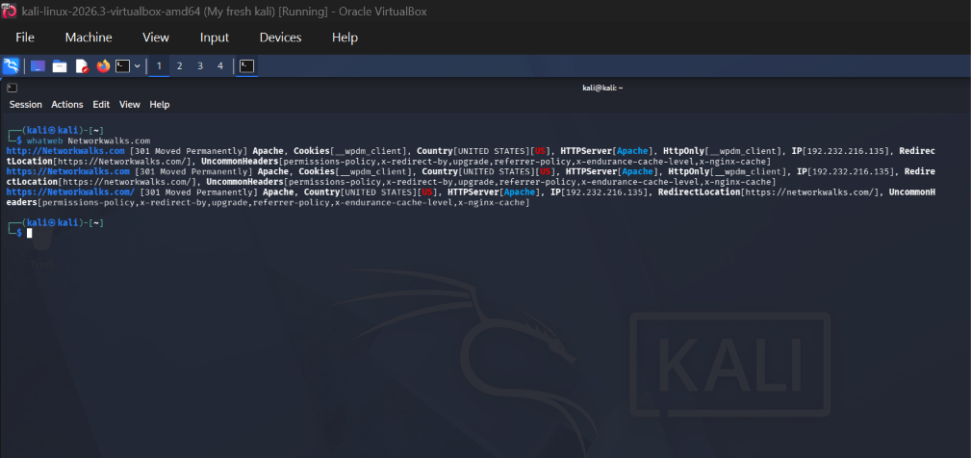
- Evidence 3 (Nslookup Output): 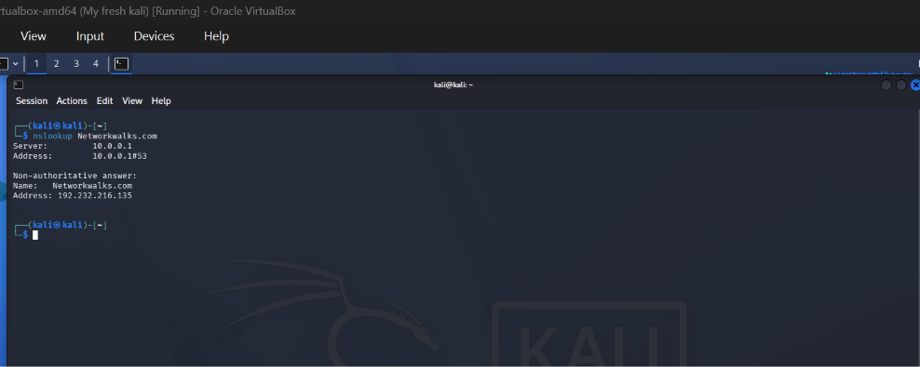
- Evidence 4 (Curl Headers Output): 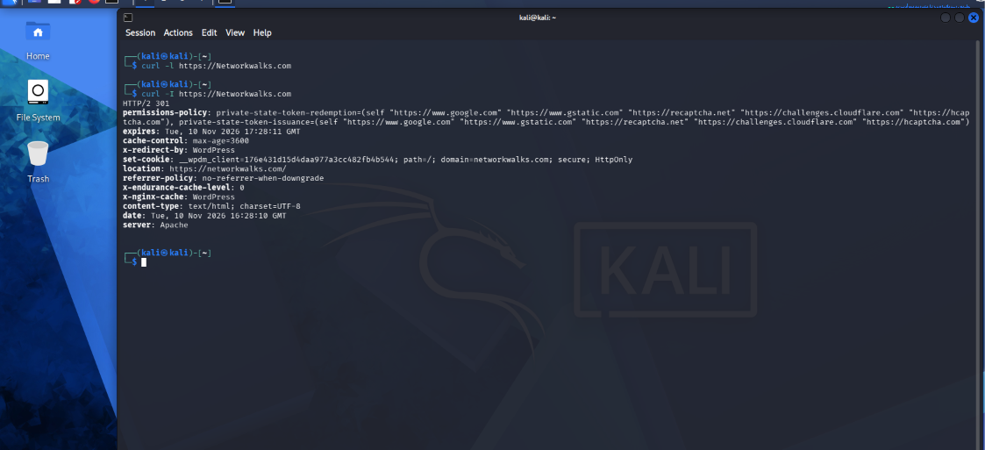
- Evidence 5 (Wafw00f Output): 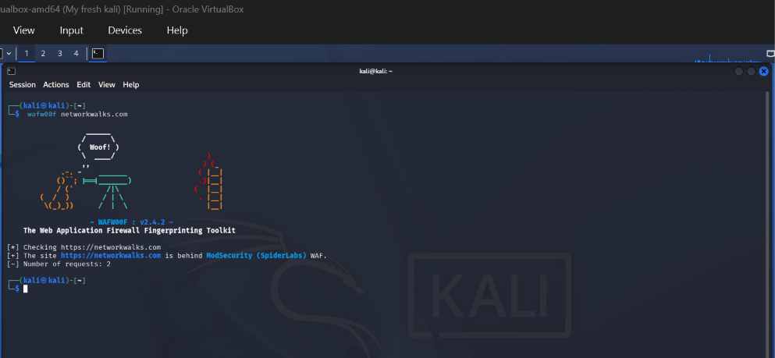
- Evidence 6 (DNSRecon Output): 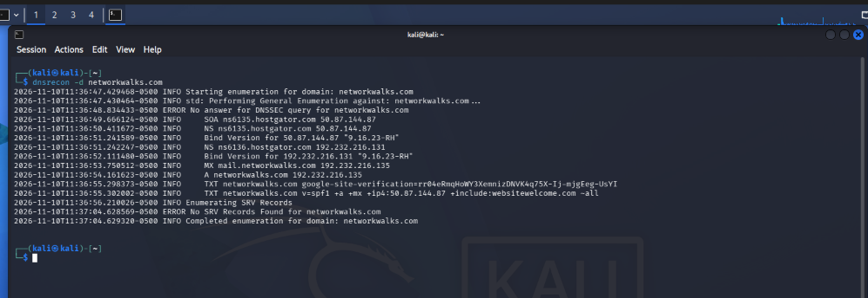
- Evidence 8 (Zenmap Ping Scan): 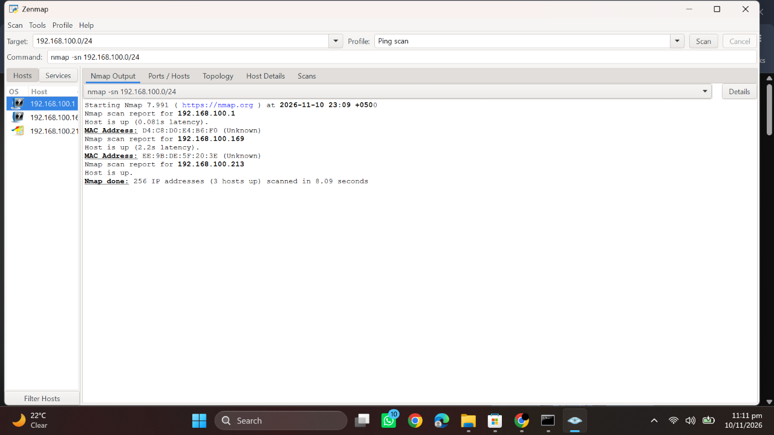
- Evidence 9 (Zenmap Topology): 

